Linkage of courses 2014/15.
connection of courses is necessary to prepare transcript of records. You will be removed from the unliked courses after 22nd of October 2014.
- Enter STUDENT’S SECTION TAB
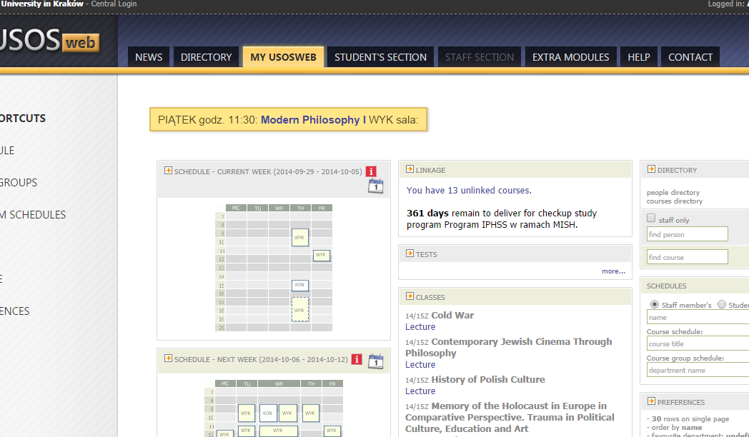
1. Choose Student’s Section
- Enter MY STUDIES section

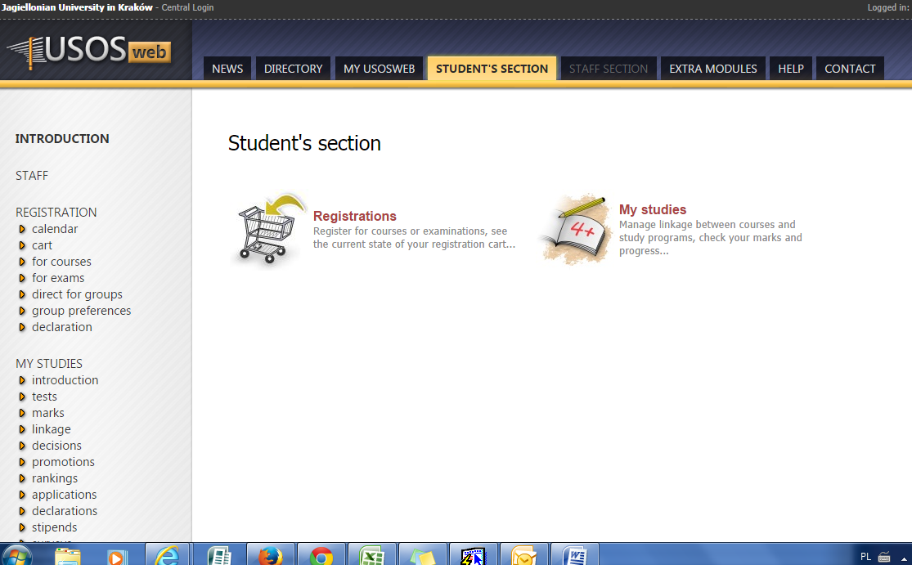
3.